ASSIGNMENT NO.3.
Aim :-
There are flight paths between cities. If there is a flight between city A and city B then there is an edge between the cities. The cost of the edge can be the time that flight takes to reach city B from A, or the amount of fuel used for the journey. Represent this as a graph. The node can be represented by airport name or name of the city. Use adjacency list representation of the graph or use adjacency matrix representation of the graph. Justify the storage representations used .

Objective:- To learn adjacency list representation of graph.
Theory:-
Following two are the most commonly used representations of a graph.
1. Adjacency Matrix
2. Adjacency List
There are other representations also like, Incidence Matrix and Incidence List. The choice of the graph representation is situation specific. It totally depends on the type of operations to be performed and ease of use.
Adjacency Matrix:
Adjacency Matrix is a 2D array of size V x V where V is the number of vertices in a graph. Let the 2D array be adj[][], a slot adj[i][j] = 1 indicates that there is an edge from vertex i to vertex j. Adjacency matrix for undirected graph is always symmetric. Adjacency Matrix is also used to represent weighted graphs. If adj[i][j] = w, then there is an edge from vertex i to vertex j with weight w.

The adjacency matrix for the above example graph is:
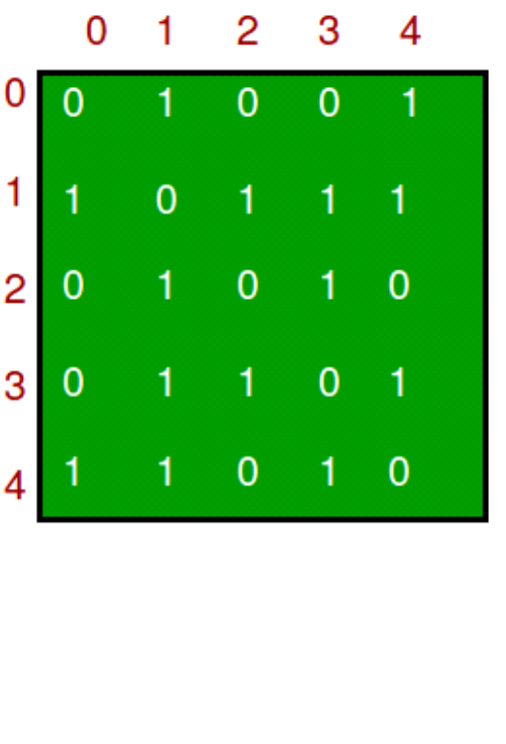
Adjacency List:
An array of lists is used. Size of the array is equal to the number of vertices. Let the array be array[]. An entry array[i] represents the list of vertices adjacent to the ith vertex. This representation can also be used to represent a weighted graph. The weights of edges can be represented as lists of pairs. Following is adjacency list representation of the above graph.

Algorithm:-
1.BFS :-
- Step 1: SET STATUS = 1 (ready state)
for each node in G
- Step 2: Enqueue the starting node A
and set its STATUS = 2
(waiting state)
- Step 3: Repeat Steps 4 and 5 until
QUEUE is empty
- Step 4: Dequeue a node N. Process it
and set its STATUS = 3
(processed state).
- Step 5: Enqueue all the neighbours of
N that are in the ready state
(whose STATUS = 1) and set
their STATUS = 2
(waiting state)
[END OF LOOP]
- Step 6: EXIT

2.DFS :-
- Step 1: SET STATUS = 1 (ready state) for each node in G
- Step 2: Push the starting node A on the stack and set its STATUS = 2 (waiting state)
- Step 3: Repeat Steps 4 and 5 until STACK is empty
- Step 4: Pop the top node N. Process it and set its STATUS = 3 (processed state)
- Step 5: Push on the stack all the neighbours of N that are in the ready state (whose STATUS = 1) and set their
STATUS = 2 (waiting state)
[END OF LOOP]
- Step 6: EXIT
Program Code:-

#include <iostream>
#include<iomanip>
using namespace std;

const int MAX=30;

class Queue //Queue for BFS TRAVERSAL
{
int front,rear;
string data[MAX];
public:
Queue()
{
front=-1;
rear=-1;
}
bool empty()
{
if(rear==-1)
return 1;
else
return 0;
}
bool inqueue(string str)
{
if(front==-1 && rear==-1)
{
front=rear=0;
data[rear]=str;
return true;
}
else
{
rear=rear+1;
data[rear]=str;
return true;
}
}
string dequeue()
{
string p;
if(front==rear)
{
p=data[front];
front=-1;
rear=-1;
}
else
{
p=data[front];
front=front+1;
}
return p;
}

};

class node //node class for each airport
{
node *next;
string city;
int timeCost;
public:
friend class graph;
node()
{
next=NULL;
city="";
timeCost=-1;
}
node(string city,int weight)
{
next=NULL;
this->city=city;
timeCost=weight;
}
};
class graph //Contains total graph of airports
{
node *head[MAX];
int n;
int visited[MAX];
public:
graph(int num)
{
n=num;
for(int i=0;i<n;i++)
head[i]=NULL;
}
void insert(string city1,string city2,int time);
void insertUndirected(string city1,string city2,int time);
void readdata(int gType);
int getindex(string s1);
void outFlights();
void inFlights();
void DFS(string str);
void BFS();
void dfsTraversal();

};
void graph::BFS()
{
string str=head[0]->city;
int j;
//node *p;
for(int i=0;i<n;i++)
visited[i]=0;
Queue queue;
queue.inqueue(str);
int i=getindex(str);
cout<<"BFS Traversal: \n";
cout<<" "<<str<<" ";
visited[i]=1;
while(!queue.empty())
{
string p=queue.dequeue();
i=getindex(p);

//visited[i]=1;

for(node *q=head[i];q!=NULL;q=q->next)
{
i=getindex(q->city);
str=q->city;
if(!visited[i])
{
queue.inqueue(q->city);
visited[i]=1;
cout<<" "<<str<<" ";
}
}
}
cout<<"\n";
}
void graph::dfsTraversal()
{
for( int i=0;i<n;i++)
visited[i]=0;
cout<<"\nDFS TRAVERSAL: \n";
DFS(head[0]->city);
cout<<"\n";
}
void graph::DFS(string str)
{
node *p;
int i=getindex(str);

cout<<" "<<str<<" ";
p=head[i];
visited[i]=1;
while(p!=NULL)
{
str=p->city;
i=getindex(str);
if(!visited[i])
DFS(str);
p=p->next;
}

}
void graph::inFlights()
{
int count[n];
for(int i=0;i<n;i++)
count[i]=0;
cout<<"====== In degree =========\n";
for(int i=0;i<n;i++)
{
cout<<"\n"<<setw(8)<<"Source"<<setw(8)<<"Destin."<<setw(8)<<"Time";
for(int j=0;j<n;j++)
{
node *p=head[j]->next;
while(p!=NULL)
{
if(p->city==head[i]->city)
{
count[i]=count[i]+1;
cout<<"\n"<<setw(8)<<head[j]->city<<setw(8)<<head[i]->city<<setw(8)<<p->timeCost;
}

p=p->next;
}
}
cout<<"\nFlights to "<<head[i]->city<<" = "<<count[i]<<endl;
cout<<"-------------------------------------\n";
}

}
void graph::outFlights()
{
int count;
for(int i=0;i<n;i++)
{
node *p=head[i]->next;
count=0;
cout<<"\n"<<setw(8)<<"Source"<<setw(8)<<"Destin."<<setw(8)<<"Time";
if(p==NULL)
{
cout<<"\nNo Flights from "<<head[i]->city;
}
else
{
while(p!=NULL)

{
cout<<"\n"<<setw(8)<<head[i]->city<<setw(8)<<p->city<<setw(8)<<p->timeCost;
count++;
p=p->next;
}
}
cout<<"\nNo. of flights: "<<count<<endl;;
cout<<"-------------------------------------\n";
}
}
int graph::getindex(string s1)
{
for(int i=0;i<n;i++)
{
if(head[i]->city==s1)
return i;
}
return -1;
}
void graph::insert(string city1,string city2,int time)
{
node *source;
node *dest=new node(city2,time);

int ind=getindex(city1); //for getting head nodes index in array
if(head[ind]==NULL)
head[ind]=dest;
else
{
source=head[ind];
while(source->next!=NULL)
source=source->next;
source->next=dest;
}
}
void graph::insertUndirected(string city1,string city2,int time)
{
node *source;
node *dest=new node(city2,time);
node *dest2=new node(city1,time); //for second flight insertion

int ind=getindex(city1); //for getting head nodes index in array
int ind2=getindex(city2);
/* if(head[ind]==NULL && head[ind2]==NULL) //when no flights in graph
{
head[ind]=dest;
head[ind2]=dest2;
}
else if(head[ind]==NULL && head[ind2]!=NULL) //no flight in first list but flight in second list
{
head[ind]=dest; //inserted first flight
source=head[ind2];
while(source->next!=NULL)
source=source->next;
source->next=dest2;
}
else if(head[ind]!=NULL && head[ind2]==NULL)
{
head[ind2]=dest2; //inserted first flight
source=head[ind];
while(source->next!=NULL)
source=source->next;
source->next=dest;
}
else
{*/
source=head[ind];
while(source->next!=NULL)
source=source->next;
source->next=dest;

source=head[ind2];
while(source->next!=NULL)
source=source->next;
source->next=dest2;

//}
}
void graph::readdata(int gType)
{
string city1,city2,tmpcity;
int fcost;
int flight;
cout<<"\nENter City Details:\n ";
for(int i=0;i<n;i++)
{
head[i]=new node;
cout<<"Enter City "<<i+1<<" ";
cin>>tmpcity;
head[i]->city=tmpcity;
}
cout<<"\nEnter Number of Flights to insert: ";
cin>>flight;
if(gType==1)
{
for(int i=0;i<flight;i++)
{
cout<<"\nEnter Source:";
cin>>city1;
cout<<"Enter Destination:";
cin>>city2;
cout<<"Enter Time:";
cin>>fcost;
insert(city1,city2,fcost);
}
}
else
{
for(int i=0;i<flight;i++)
{
cout<<"\nEnter Source:";
cin>>city1;
cout<<"Enter Destination:";
cin>>city2;
cout<<"Enter Time:";
cin>>fcost;
insertUndirected(city1,city2,fcost);
//cout<<"\ninserted"<<i+1;
}
}
}
int main() {
int number,choice;
int graphype;
cout<<"-------INDIA AIRLINES PVT LTD--------"
<<"\n0. Undirected\n1.Directed\nEnter Flight data Insertion Type:";
cin>>graphype;
cout<<"\nENter Number of Airport Stations:";
cin>>number;
graph g1(number);
g1.readdata(graphype);
do
{
cout<<"-------- Menu --------"
<<"\n1.Incoming Flights(In degree)"
<<"\n2.Outgoing Flights(Out degree)"
<<"\n3.DFS"
<<"\n4.BFS"
<<"\n5.Exit"
<<"\nEnter your choice: ";
cin>>choice;
switch(choice)
{
case 1:
cout <<"" << endl;
g1.inFlights();
break;
case 2:
g1.outFlights();
break;
case 3:
g1.dfsTraversal();
break;
case 4:
g1.BFS();
break;
default:
cout<<"\nWrong Choice";
}
}while(choice!=5);

return 0;
}

Output Screenshots:-
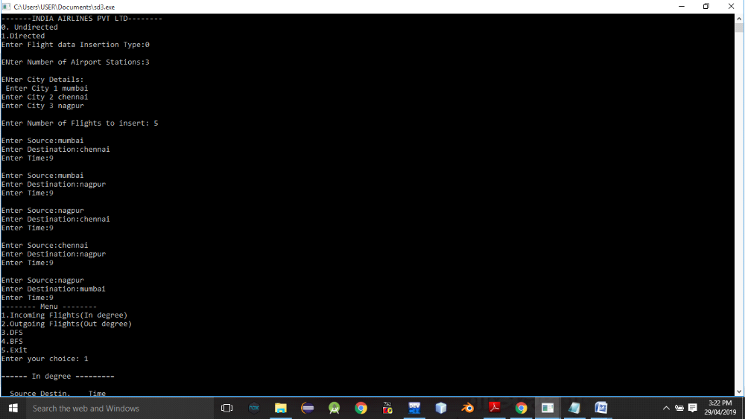
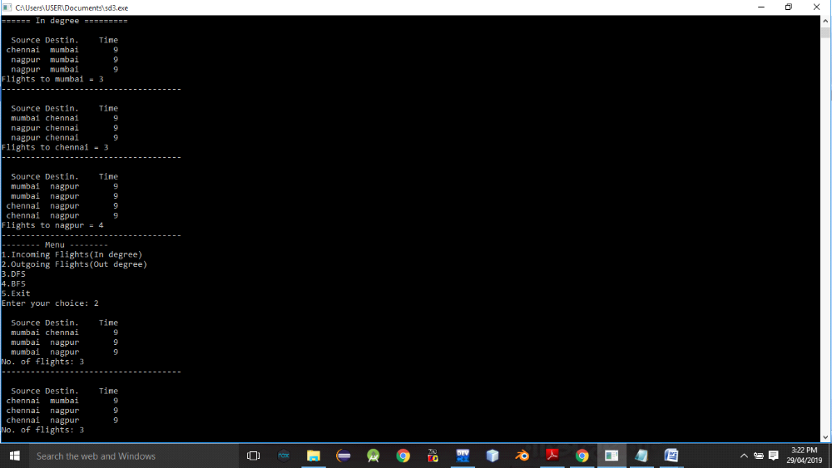
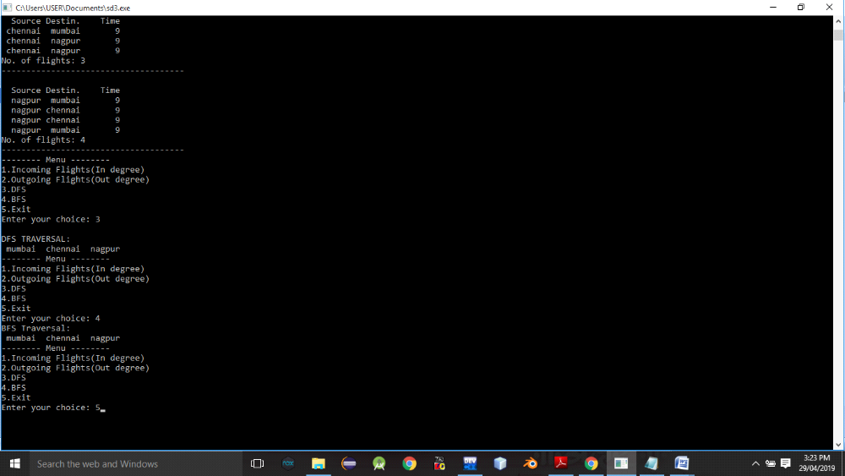

Conclusion:- Thus,we have studied adjacency graph representation.

